Chapter 6, Solution 57.

Let 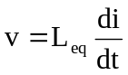 (1)
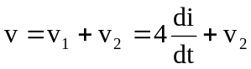 (2)
i = i₁ + i₂ i₂ = i – i₁ (3)

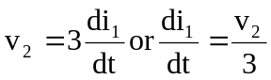 (4)

and
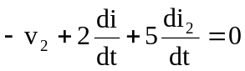
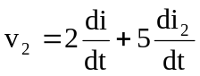 (5)

Incorporating (3) and (4) into (5),

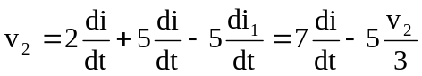

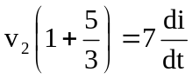
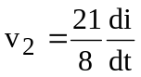

Substituting this into (2) gives

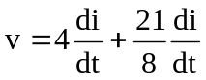

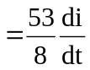

Comparing this with (1),
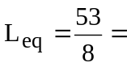6.625 H

